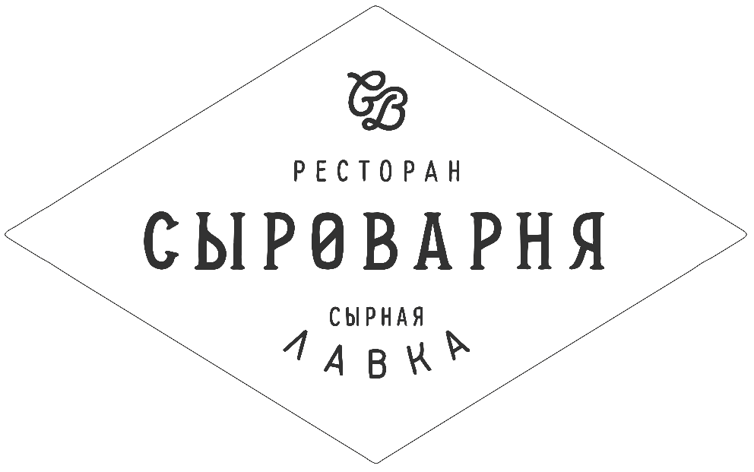
White wine / Белые вина
France / Франция
Petit Chablis, Savary .../ Bourgogne /.............................. 3 600 ₽ Muscadet, Chateau de La Tibodies …/ Val de Loire /...2 100 ₽ Gewurztraminer, Gustave Lorentz ...../ Alsace /............. 3 900 ₽ Riesling, Gustave Lorentz ……/ Alsace /......................... 3 300 ₽ Dourthe № 1 Blanc ……/ Bordeaux /.............................. 2 700 ₽ Chablis Premier Cru, Billaud-Simon .../ Bourgogne /... 8 000 ₽

Italy / Италия
Gavi di Gavi, Marchesi di Barolo .../ Piemonte /............ 4 800 ₽ Chardonnay, Bottega Vinai …/ Trentino-Alto-Adige /...2 400 ₽ Vermentino, Prestige ...../ Toscana /................................. 2 100 ₽ Pinot Grigio, Italo Cescon ……/ Friuli /............................ 2 700 ₽ а
Other World / другие страны
Albarino, Mar de Frades .../ Spain /.................................. 3 300 ₽ Verdejo, Cuatro Ryas …/ Spain /........................................2 150 ₽ Riesling, Landgraf von Hessen ...../ Germany /.............. 2 600 ₽ Gruner Veltliner ……/ Austria /......................................... 2 100 ₽ Chardonnay, d'Arenberg .../ Australia /........................... 3 100 ₽ Chardonnay, Cool Woods …/ Australia /..........................2 500 ₽ Sauvignon Blanc, Caroline Bay ...../ New Zeeland /...... 2 200 ₽ Sauvignon Blanc, Maule Valley ……/ Chilie /................ 1 800 ₽ а
Rose / Розовое
Zweigelt Rose fresh & easy ......... / Austria /................... 2 200 ₽ Rose Infinie Cotes De Provence .... / France /................. 2 800 ₽

ШАМПАНСКОЕ
Veuve Clicquot Brut / Rose ................................ 0,75 l ... 10500 ₽ Moet & Chandon Imperial / Rose Imperial ... 0,75 l ... 10500 ₽ Dom Perignon Vintage ....................................... 0,75 l ... 31500 ₽

By Glass / По Бокалам
Sparkling / Игристое
Martini Prosecco .../ Italy /..................................187 ml....... 600 ₽ Pinot Grigio Rose Spumante Extra Dry../ Italy /.150 ml... 350 ₽ а
White / Белое
Riesling Mosel, Michel Scheid .../ Germany /.....150 ml... 350 ₽ Sauvignon Blanc, TAKA .../ New Zealand /........150 ml.... 350 ₽ Pinot Grigio, SanVigilio .../ Italy /.........................150 ml..... 300 ₽

Rose / Розовое
Zweigelt Rose fresh & easy ..... / Austria /........ 150 ml ... 450 ₽ а
Red / Красное
Chianti, Rondone .../ Italy /.................................150 ml....... 300 ₽ Shiraz, Jumango .../ Australia /.........................150 ml....... 300 ₽ Tempranillo, Mr Liebre organic .../ Spain /......150 ml...... 300 ₽

аSparkling wine / Игристые вина
Cremant, Tresors de Loire .../ France /............................. 2 600 ₽ Cava, Delapierre Brut .../ Spain /...................................... 1 800 ₽ Martini Prosecco .../ Italy /................................................... 3 100 ₽ Martini Asti .../ Italy /............................................................. 3 500 ₽

Red wine / Красные вина
France / Франция
Pinot Noir, Lugny l’Aurore .../ Bourgogne /..................... 3 000 ₽ Dourthe Grands Terroirs …/ Bordeaux /...........................1 750 ₽ Domaine de la Presidente ...../ Cotes du Rhone /......... 2 500 ₽ Domaine des Chanssaud ./ Chateauneuf-du-Pape /... 7 000 ₽ Pinot Noir, Gustave Lorentz ……/ Alsace /..................... 3 900 ₽ Château Leboscq Medoc Cru Bourgeois / Bordeaux /. 3 850 ₽ а
Italy / Италия
Nero d’Avola, Rondone .../ Sicilia /.................................... 1 650 ₽ Barbera d`Alba, Croere …/ Piemonte /............................4 000 ₽ Beni di Batasiolo ...../ Barbaresco /................................... 6 500 ₽ Chianti Classico, Torre a Destra ……/ Toscana /.......... 6 200 ₽ Nero d`Avola-Cabernet, BIO Terre ...../ Sicilia /............. 2 700 ₽ Valpolicella Classico, Viviani ……/ Veneto /.................. 2 800 ₽ а
Other World / другие страны
Rioja, Monte Llano .../ Spain /............................................ 1 700 ₽ Rioja Beronia, Reserva …/ Spain /.....................................4 000 ₽ Rioja, Ramón Bilbao ...../ Spain /........................................ 3 300 ₽ Rioja Gran Reserva, Ramón Bilbao ……/ Spain /.......... 4 500 ₽ Shiraz, Scarlett Runner .../ Australia /............................... 3 600 ₽ Malbec Classic, Alta Vista …/ Argentina /.......................2 100 ₽ Malbec, Luca Mendoza ...../ Argentina /.......................... 5 300 ₽ Malbec, Viu Manent ……/ Chilie /.................................... 1 750 ₽ Carmener-Syrah Reserva, Maule Valley …/ Chilie /... 2 000 ₽ Pinotage, Diemersdal ……/ South Afrika /..................... 3 600 ₽ Simonsig Tiara ……/ South Afrika /.................................. 3 800 ₽ Murphy Goode ……/ USA /................................................ 3 000 ₽ а
Porto & Jerez
Maynard’s Fine Ruby Porto ... / Portugal /.......................... 400 ₽ Jerez Nectar Pedro Ximenez Dulce ... / Spain /................. 450 ₽

